Chattering reduction in step down converter using Robust reaching law

Mr.Sridhara Somaguddu.Ningappa¹, Dr.Siddesh Kondapur Basavarajan², Mr.Sudharashan M.K³, Sandeep Vellore⁴ Lavakumar T.B⁵

¹ Department of Electronics and Communication Engineering, SJM Institute of Technology, VTUniversity, Belagavi, Karanataka India
²Department of Electronics & Communication Engineering, SJM Institute of Technology, VTUniversity, Belagavi, Karanataka India
³Department of Electronics & Communication Engineering, SJM Institute of Technology, VTUniversity, Belagavi, Karanataka India
⁴Department of Electronics & Communication Engineering, SJM Institute of Technology, VTUniversity, Belagavi, Karanataka India
⁵ Department of Electronics and Communication Engineering, SJM Institute of Technology, VTUniversity, Belagavi, Karanataka India

Article Info |  | ABSTRACT
Article history:  Received month dd, yyyy  Revised month dd, yyyy  Accepted month dd, yyyy |  | The robust reaching law based sliding mode control is used for chattering suppression, minimization of steady state error and reaching speed kept minimsed. With fine tuning of parameters of robust reaching law, the sliding mode reaches the equilibrium point at the earliest. The stability of the proposed reaching law is analyzed. In one hand, they guarantee the system reach the sliding surface rapidly and remain on it, in another way they deteriorate the chattering effectively, even unmatched certainties and disturbances. Such that the system response can better realize the unification of rapidity. A proposed reaching law ia analysed mathematically and applied to SMC DC-DC buck converter to lessen the chattering, because switching devices are existing in the model, it reduces the switching losses in the switching devices of the dc-dc converter. In turn effectiveness of the buck converter increases. MATLAB/Simulink results gives significant decline of chattering.
Keywords:
Reaching law
Robust reaching law
Chattering
Sliding mode control
This is an open access article under the CC BY-SA license.

Corresponding Author:
Dr.Siddesh Kondapur Basavarajan²
Department of Electronics and Communication Engg.
SJM Institute of Technology,VTUniversity,Belagavi.577501,India
Email: kondapur.b@gmail.com

- INTRODUCTION

Sliding Mode Control (SMC) is a nonlinear control systems design technique which is robust adjacent to parameter variations and matched uncertainties. It evolved from the Variable Structure Control (VSC) and is established in the field of nonlinear control. Details of sliding mode control can be obtained in [1] [2] [3]. In the Sliding Mode Control a reaching law takes the system states in the sliding surface at limited time interval. Once the condition of the system reaches the sliding line the switching control causes chattering. The chattering regularity is infinite and its amplitude towards zero. However, in realistic systems due to the dynamics of the Electronics sensors and actuators etc., the chattering frequency is finite and also has some amplitude [4]. In mechanical systems this can result in high bear and losses, as an effect becoming infeasible for use in such systems, on the other hand in high speed electronics it can result in enormous variations in the fixed state presentation resulting in unacceptable systems. a number of methods have been proposed in various research works for explanatory the chattering effect. In [5], VSC along with non sliding methods were used for eliminate the high frequencies by achieving the elimination of chattering. In [6], tuned sigmoid functions were implemented to weaken the chattering. In [7], power rate reaching law was implemented for the alleviation of chattering. Higher order sliding mode wakened the chattering [8] [9]. Smooth Sliding Mode [10] [11][12]Suppressed the chattering however, it was not considered robust against the parameter variations and matched uncertainties, which increased the complexity of the smooth sliding mode control. The different Reaching law structures explained that chattering alleviation and convergence speed, minimization of steady sate errors, robustness explained[13][14]However, the further application of SMC is limited because of the chattering phenomenon, which can excite high frequency dynamics. Thus, some approaches have been proposed to overcome this problem. Continuation control method can solve this problem effectively. Though this method could restraint the high-frequency chattering, it also destroys the sliding mode [15]. Another method of restraining chattering is higher order sliding mode control, which can eliminate the discontinuous term in control input [16]. In this reaching law technique which is used to chattering mitigation can obtain the control law easily [17][18][19]. The problem identified that in the proposed work is chattering in SMC, due to chattering more swirtching losses in the step down converter and not obeying the sliding mode condition rule.

2. MATHEMATICAL ANALYSIS OF ROBUST REACHING LAW (RRL)

A new RL, called RRL, is described in this section. The proposed RRL is described in vector format as
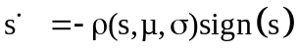 (1)
where σ is a positive integer, 0 < σ < 1; μ is a constant, 0 < μ < 1
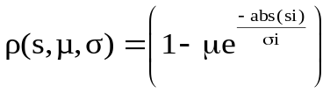 (2)
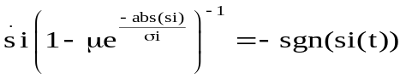 (3)
Integrating with respect to time, reaching time can be calaculated as follows.
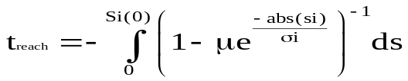 (4)
When si (t)>0, for negative values
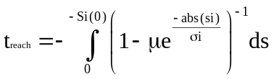 (5)
When si (t) <0, positive values
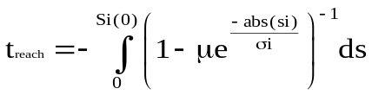 (6)
When combined both equation (5) and (6) the reaching time,
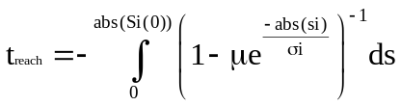 (7)
As a final point, we get
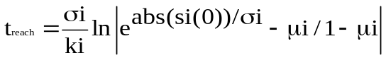 (8)
The proposed reaching laws µ bring the system on to the slidng line,by dereasing the value of µ ,causes a delay in approaching on to the sliding line, if µ value increases the speed of the system states on the trajectory path, whereever the intial conditions of states. σ makes the states to fast speed kept. If the value of σ reduces, the chattering effect can be minimized and the reaching time kept fast by appropriate selection of σ and µ values, and reduces the chattering at the orign of the slidng surface. The absolute values of the‘s’ bring the stabilty of the system on the switching surface.

2.1 SMC with Robsut Reaching Law

Slidng mode control with robust reaching law is given by

State variable eqaution is given by
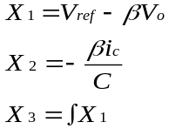 (9)
Where X₁ X₂ and X₃ are state variables.

  - The constant plus proportional rate reaching law or traditional reaching law:
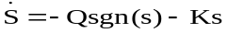 (10)
Q > 0 and K> 0 are positive constants
(11)
Using equation (1) and (11), we get (Using Control Law)
(12)
Where A and B are matrix coefficients of the step down converter parameters.Euation (12) represents the control law,
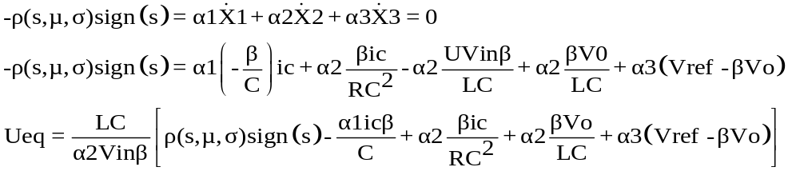 (13)
Equation (1) and eaution (12) gives the equivalent value of the input and it’s implemented using Simulink
3. CHATTERING
The chattering is tearness and wearness of the system, it reduces the effieiciency of the buck converter and also makes more noises in the system. The effect of chattering in the step down converter is that more deviated in the output voltage. Figure 2 shows the chattering in SMC. Chattering phenomena is unwanted possessions of variable structure system. The main grounds of chattering a phenomenon is the existence of sign function in control inputs. The chattering has more oscillation at the origin, this causes a more haet losses in system, the sliding line shoud end with the origin of the system. The chattering is the main drawback of the sliding mode control systems [21, 22]. The trajectory is the path in which slidng line passed through it. Figure 1 represents the chattering on the switching surafce

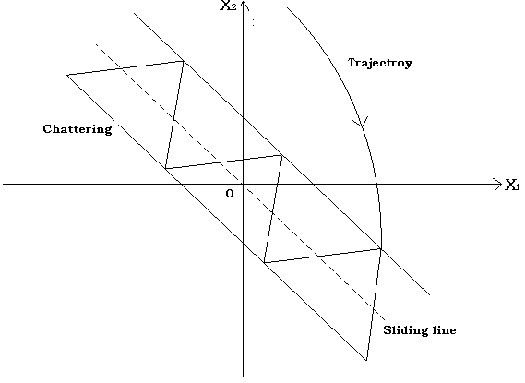
Figure 1 Chattering

4. SIMULATION RESULTS

Table 1: Specifications of step down converter and proposed reaching law

Sl.No. | Parameter | Symbol | Value
1 | Input voltage | Vi | 24Volts
2 | Capacitance | C | 220μF
3 | Inductance | L | 69µH
4 | Switching Frequency | fs | 200KHz
5 | Minimum load resistance | R_{L}(min) | 6 Ohm
6 | Maximum load resistance | R_{L}(max) | 10 Ohm
7 | Desired Output voltage | Vod | 12V
8 | Reference voltage | Vref | 12V
9 | m1 &m2 (Parameters) |  | 2,3
10 | k₁ and k₂(Parameters) |  | 1,  0.5
11 | Feedback factor | β | 0.99
11 | sliding coefficients, | α₁  α₂  α3 | 3  25  2000
12 | Duty cycle | α | 0.5
13 | Efficiency of the Converter | η | 0.91
14 | Input Power | Pi | 14.2W
15 | Output Power | Po | 12.9W

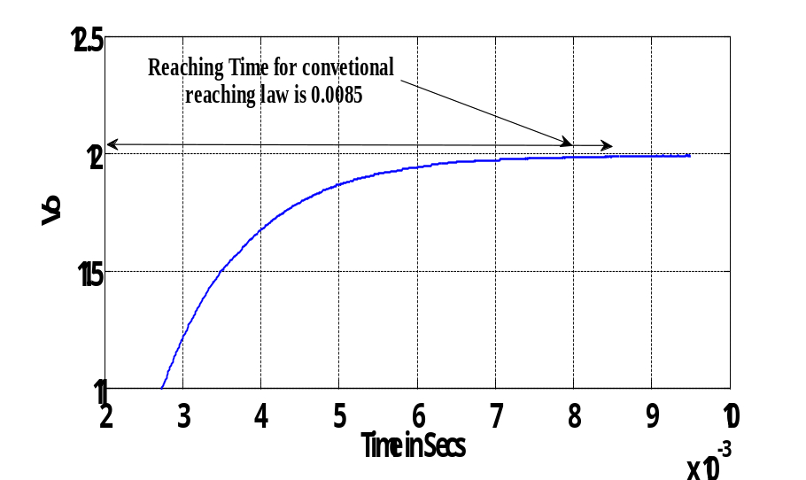
Figure 2 Output voltage of Traditional reaching law

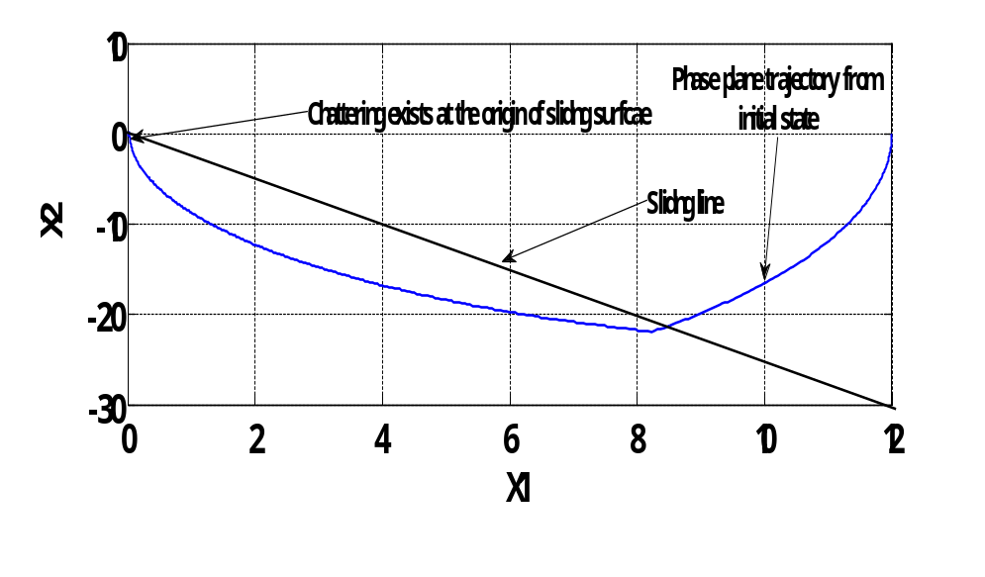
Figure 3 Chattering of Robust reaching law
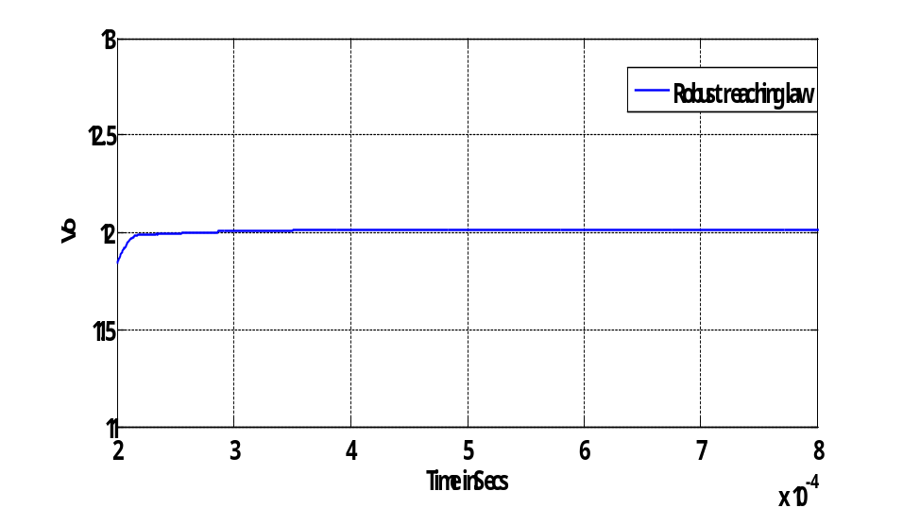

Figure 4 Output voltage of Robust reaching law

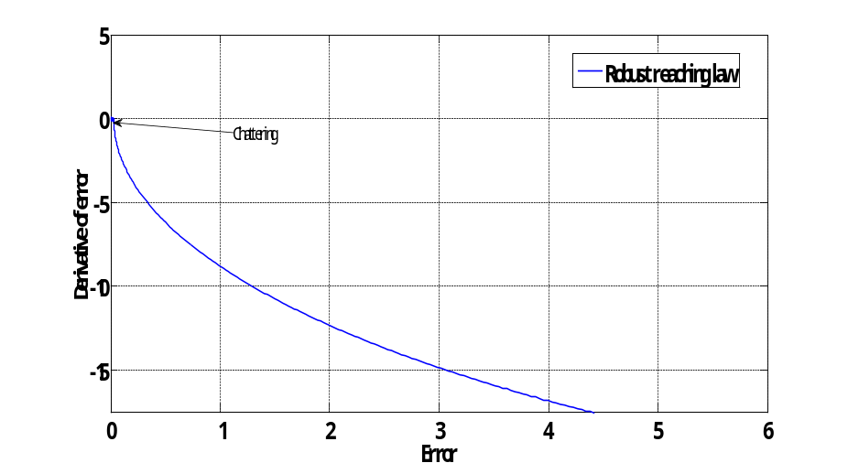
Figure 5 Chattering of Robust reaching law.

Table 2: Comparison of robust reaching law with traditional reaching law

Parameters | Proposed robust reaching law | Constant plus proportional rate reaching law
Settling time | 0.2msecs | 0.7msecs
Chattering  Amplitude | 0n x-axis  0 to 0.03  On y-axis  -0.08 to 0.085 | 0n x-axis  2.5 to 0  On y-axis  -0.25 to 0.25
Reaching time  To steady state | 0.00025Secs | 0.0085Secs

The table 1 gives the specifiaction of the reaching law and step down converter. Figure 2 represents the output voltage of the traditional reaching law, it takes the long time to reach the desired output voltage, due to effect of chattering. Figure 3 represents the chattering of robust reaching law, the Robust reaching law obeys the rule of the sliding surface. Figure 4. Represents the ouput voltage of the Robust reaching law. The proposed reaching law brings the output voltage nearby the origin at minimum time. Figure 5 represents the chattering at the origin of a robust reaching law. Overall performanace of the step down converter is improved. From Table 2 represents the settlimng time, amplitude and reaching time of the robust reaching law and traiditional reaching law. A proposed robust reaching law gives dynamic and mitigates the chattering effectively than the the traditional reaching law.

5. CONCLUSION

In this paper we discussed the robust reaching law with conventional reaching law about the chattering mitigation and newly designed robust reaching law effectively reduces the chattering and system remains on sliding surfaces. Both reaching laws are applied to DC-DC step down converter. The dynamic performance of the system can be effectively improved by changing the value of the reaching law parameters. Switching losses can be minimsed in the step down converter. The simulation results show that the proposed robust reaching law exhibits superior static and dynamic properties than the constant plus proportional rate reaching law

REFERENCES

[1] V. Utkin, Sliding Modes in Control and Optimization, Berlin: Springer, 1992.
[2] John Y. Hung, Weibing Gao, and James C. Hung, Variable Structure Control: A Survey IEEE Transactions On Industrial
Electronics, Vol. 40, No. 1, Feb 1993
[3] V. Utkin, J. Guldner and J. Shi, Sliding Mode Control in Electromechanical Systems, Taylor & Francis, 1999.
[4] C. Edwards and S. K. Spurgeon, Sliding Mode Control Theoryand Applications, Taylor & Francis, 1998.
[5] K. David Young, Vadmin I. Utkin,Umit Ozguner Guide to Sliding Mode Control, IEEE Transactions on Control Systems
Technology, vol. 7, no. 3, May 1999.[6] J. T. Moura and N. Olgac, Robust Lyapunov control with perturbation estimation, IEE
Proceedings - Control Theory and Applications, vol. 145, pp. 307-315, May 1998.
[7] O. Camacho, R. Rojas and W. García, Variable structure control applied to chemical processes, ISA Transactions, vol. 38, pp. 55-72,
1999.
[8] W. Gao and J. C. Hung, Variable structure control of nonlinear systems, IEEE Transactions on Industrial Electronics, vol. 40, no. 1,
pp. 45-55, Feb 1993.
[9] T. Floquet, J.-P. Barbot and W. Perruquetti, Higher-order sliding mode stabilization for a class of nonholonomic perturbed systems,
Automatica, Science directpp. 1077-1083, June 2003.
[10] A. Levant, "Higher order sliding modes and arbitrary-order exact robust differentiation," in Proc. of the European Control
Conference (ECC'01), 2001.
[11] Y. B. Shtessel, I. A. Shkolnikov and A. Levant, "An Asymptotic Second-Order Smooth Sliding Mode Control," Asian Journal of
Control, vol. 5, no. 4, pp. 498-504, 2003.
[12] Siew-Chong Tan, Y. M. Lai, and Chi K. Tse An Evaluation of the Practicality of Sliding Mode Controllers in DC–DC Converters
and Their General Design Issues 37th IEEE Power Electronics Specialists Conference/ June 18 - 22, 2006, Jeju, Korea
[13] Yu-Xin Zhao, TianWu, and Yan MaDouble Power Reaching Law of Sliding Mode Control Based on Neural Networ Hindawi
Publishing CorporationMathematical Problems in Enginereng Volume 2013, Article ID 408272, 9 pages

[14] Hongtao Ye,Mengmeng Li,Wenguang Luo, A novel reaching law of sliding mode control design and analysis 20-22 Oct.

2017, Pages 1803 – 1807, 2017 Chinese Automation Congress (CAC). Jinan, China.

[15] K. B. Devika, Susy Thomas Improved sliding mode controller performance through power rate exponential reaching law

Second International Conference on Electrical, Computer and Communication Technologies . 1 - 7 (ICECCT)22-24 Feb.

2017 , Pages 1 – 7, 23 November 2017 Coimbatore, India.
[16] Bing Li,Kai Su Contour control for direct drive X-Y table based on a new exponential reaching law
“ Chinese Automation Congress (CAC), 2017, 20-22 Oct. 2017, Jinan, China.
[17] H. Wang, H. Zhang, Y. Liang and W. Xiong, Reducing chattering using Adaptive Exponential Reaching Law, in Sixth international
conference on Natural Computation (ICNC), 2010.
[18] C. J. Fallaha, M. Saad, H. Y. Kanaan and K. Al-Haddad, "Sliding-Mode Robot Control using exponential Reaching Law," IEEE
Transactions on Industrial Electronics, vol. 58, no. 2, pp. 600-610, Feb 2011.
[19] Burton, J. A. and, Zinober, A. S. I., Continuous approximation of variable structure control, Int. J. Syst. Sci., Vol. 17, No. 6, pp.
875-885,1986.
[20] Fallaha, Charles J. Maarouf Saad, Hadi Youssef Kanaan and Kamal Al-Haddad, Sliding-mode tobot control with exponential
reaching law,IEEE Trans. Ind. Electron., Vol. 58, No. 2, pp. 600-610, 2011
[21] K.B. Siddesh , B. Basavaraj Chattering Analysis In Sliding Mode Controlled Dc-Dc Buck Converter Using New Novel Reaching
Law Method” Journal On Electrical Engineering ISSN : 0973-8835 Volume 10. No. 4 April - June 2017 I-Manager Publications
2017.
[22]. Liang Tao, Qiang Chen, Yurong Nan, And Chun W double Hyperbolic Reaching Law With Chattering-Free And Fast
Convergence IEEE Access Multidisciplary journal digital Object Identifier 0.1109/ACCESS.2017.DOI

