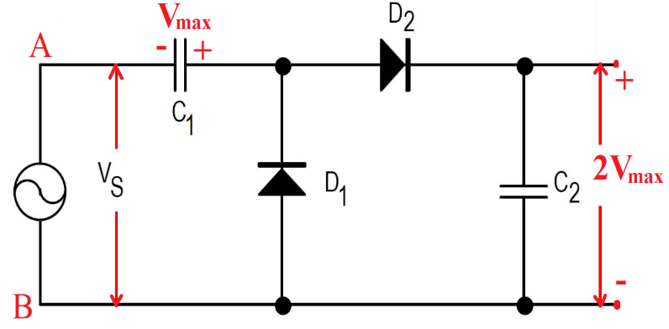
Figure 1: Voltage doubler circuit
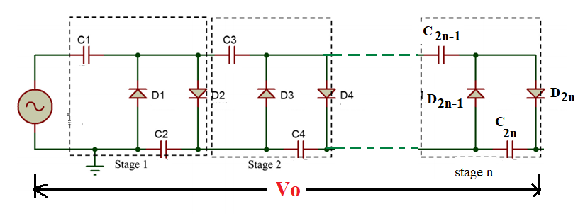
Figure 2: Voltage multiplier circuit
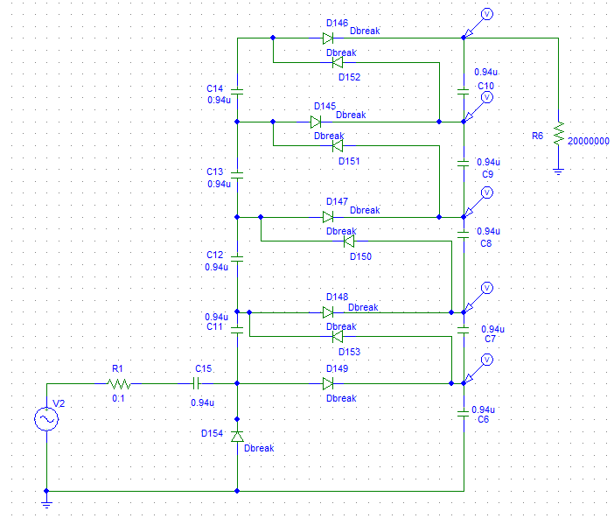
Figure 3a: Simulation circuit of a five stage generator
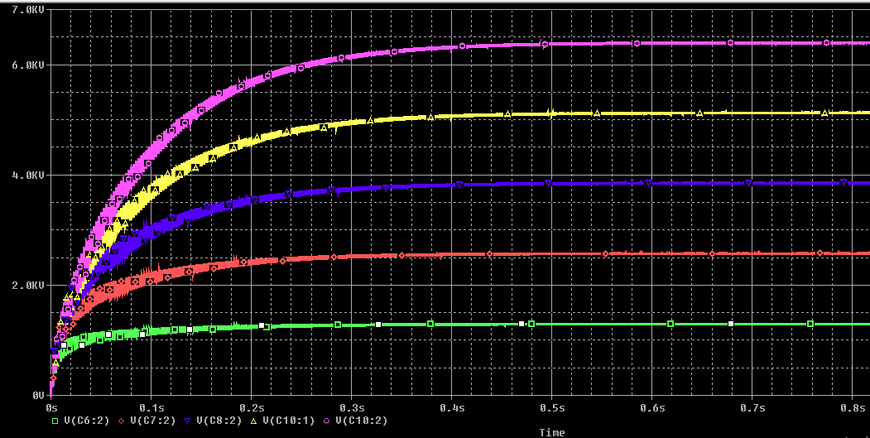
Figure 3b: Stage voltages with 20MΩ load

Figure 4: frequency versus ripple voltage for a 20 M ohm load

Figure 5: Capacitance versus ripple voltage for a 20 Mega ohm load

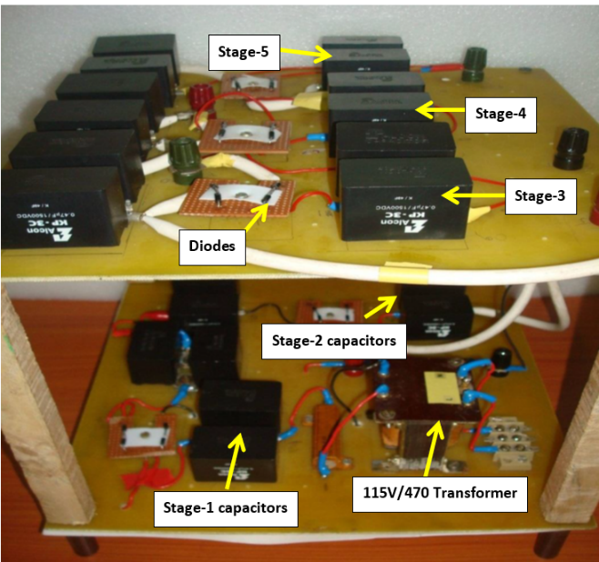
Figure 6a: Circuit with transformer, capacitors and diodes

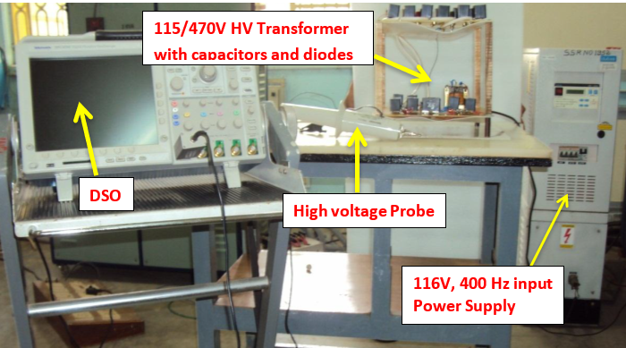
Figure 6b: whole setup connected to frequency converter and DSO

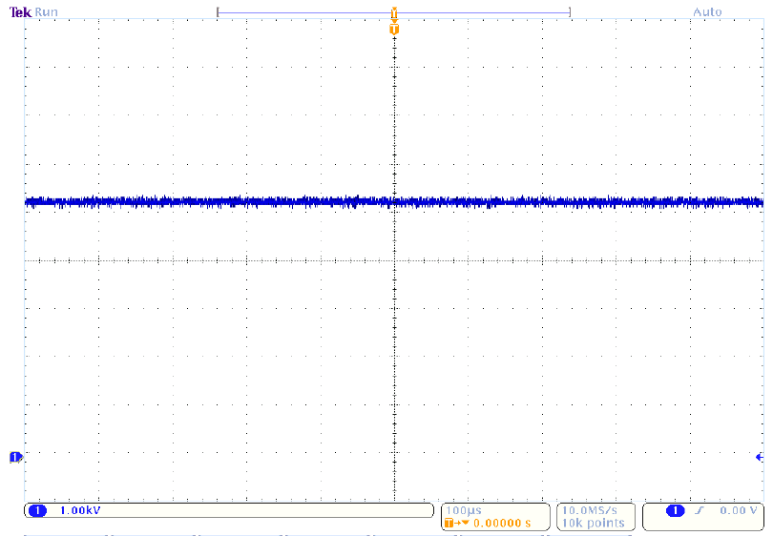
Figure 6c: Experimental output voltage waveform

Figure 7a: Load versus load current

Figure 7b: Load versus Ripple voltage

Figure 7c: Load versus voltage drop

