High-performance CUK Converter with turn-on switching at zero voltage and zero current
Basim T. Kadhem Sumer S. Hardan
Department Of Electrical Engineering Department Of Electrical Engineering
College Of Engineering College Of Engineering
University Of Basrah University Of Basrah
Basrah-Iraq Basrah-Iraq Email: basim.kadhem@uobasrah.edu.iq Email: sumer.hardan@uobasrah.edu.iq
Tel: +9647709079062 Tel:+9647722126082

Abstract: A high efficiency soft switching CUK converter is presented in this work. When the main and auxiliary switches are turned on and off at zero voltage, the proposed converter yields zero voltage and zero current. The suggested method is ideal for a DC-DC converter based on IGBTs or MOSFETs. The suggested systems are explained using theoretical analysis, computer simulation findings, and experimental data from a prototype.. As a result, efficiency is enhanced, especially under full load.
Index Terms— ZVZC, DC-DC CUK Converter

I. Introduction
Power supply for personal computers, office equipment, spacecraft power systems, laptop computers, telecommunications equipment, as well as DC motor drives, all make use of DC-DC power converters.
A soft-switched pulse-width modulation (PWM) converter, high-power applications-appropriate , has been presented [1]. High power density and high efficiency can be obtained from them, because the commutation takes place under zero-voltage or zero-current.
To lessen switching losses and EM1 sounds, Cuk converters have been frequently employed as LED drivers [2],[3],[4]. In other words, a Cuk converter has substantially greater power handling requirements for its semiconductor components than a similar output power may be achieved using either a buck converter or a boost converter. A Cuk converter places a lot of emphasis on lowering the switching losses and increasing the EM1 sounds [5].
Designing a soft switching converter is extremely difficult because of the strict limitations on the permitted current/voltage stress and conduction losses. The fact that the converter is being fed with DC as an input just serves to increase the challenge of finding a solution. It is well known that, for soft switching, a non-zero product of the switch's voltage and current must accompany the switching transition, and that, To prevent the voltage and current from canceling each other out in a DC-DC converter, a sub-circuit containing active and passive switches and resonant devices must be specially designed [6]. Resonant elements aid in bringing the current/voltage of a switch to zero before a switching transition, consequently, the switch is subjected to high current/voltage stresses.
The constant aims of switching-mode power supply development have been high efficiency and compact size [7],[8],[9],[10]. Large switching losses were being produced by the traditional hard-switching PWM converters. Quasi-resonant converters (QRC) were able to minimize the size and weight of the circuit by using a soft-switching approach that minimized switching losses and allowed for high frequency operation.
This article describes the development of the novel Cuk converter, which offers zero capacitive turn-on losses due to the converter's sophisticated design and ZVS at the commutation of the active device, for a wide line and load range of switches and recovery diode. The Cuk version was chosen because it could make voltages that were equal to or higher than the voltage that was put in.
With the switch voltage stress being lower than the output voltage, the voltage conversion ratio is also increased. Power conversion efficiency is increased as a result of low-voltage stress and switching device ZVS and ZCS operation. In-depth discussions are held on the suggested converter's design parameters, theoretical analysis and characterization, and operating principle. The suggested converter's performance is then checked by testing the experimental prototype and running simulations.

II. CONVERTER PROPOSAL ANALYSIS
The proposed converter is intended to provide ZVS (ZCS-ZVS) to the primary switch. This is achieved by integrating additional components into the conventional converter. The auxiliary component must also switch under ZCS-ZVS by itself, verifying that no additional switching loss occurs during the building of the ZVS circuit. The suggested PWM ZVT CUK converter is depicted in Fig. 1. The auxiliary devices S₁, C₁, D₃, L_{r}, and D₄ create the subsequent to provide a favourable switching state for the main device S2, while Lr and C1 form the resonant tank to provide ZVS switching. The link formed by D3 and Lr is used to remove the charge across S2 in order to provide the ZVS condition. C2 is connected in parallel with the primary switch S2 to give ZVS when the switch is turned off.
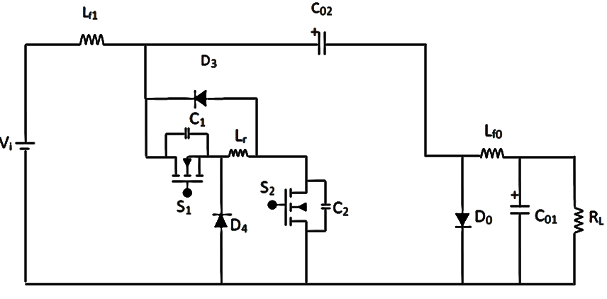

Fig.1: Schematic of the proposed PWM ZVT CUK converter.

In one switching cycle, the proposed CUK converter passes through seven topological phases, which are seen in Figs. 2 and 3-9, respectively.
Multiple assumptions are established during each switching cycle to facilitate the investigation of operation modes [1, 6].
1) All of the circuit's components are typical.
2) The inductors for both the input and output filters, L_{fi} and L_{fo}, are sufficiently large that the filters, I_{in} and I_{o}, can be treated as constant current sinks.
3) Because the output capacitors C₀₁ and C₀₂ are large enough, their voltages are set as Vo and V_{C02}, and they may be represented as constant voltage supplies.
4) The input voltage, Vi, is fixed.

DC resistances of inductors, and transistor on-resistances are all calculated. Forward voltage drops of diodes are not taken into account because the goal of the study is to discover a straightforward, strategy based on design. Fig. 2 shows how the active switches are operating. In Fig. 2, the converter's theoretical steady-state main waveforms are also depicted. As a result, each cycle of the converter has seven switching stages (Fig. 3-9). Prior to the beginning of a new cycle, the auxiliary switch S₁ was switched on and the main switch S₂ was turned off. Input and output current were carried by the rectifier diode D_{o}, while D₃ carried a constant-value inductor current (I_{in}+I_{o}).

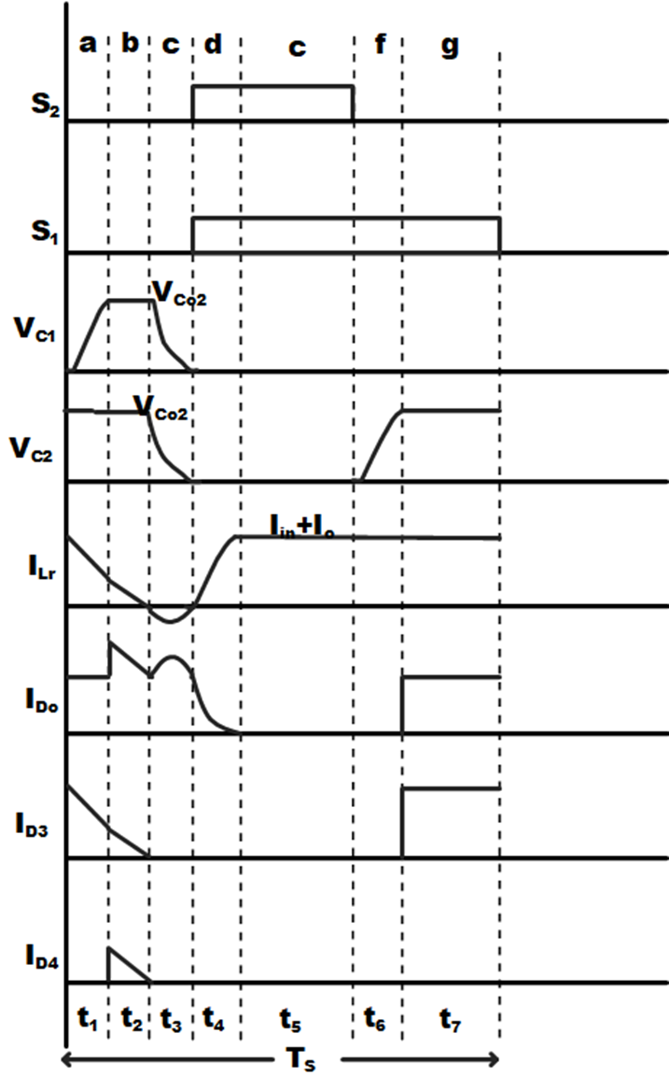

Fig. 2: The suggested converter's key waveforms
Stage a: C₁-Capacitor Charging (t_{o}-t₁):
When S1 is turned off by the clock signal, a new cycle begins. As it approaches V_{C02}, the voltage across the parasitic capacitance S₁ increases (before being clamped by D₄). D_{o} keeps carrying the combined input and output current. By resolving the linear circuit of Fig. 3.
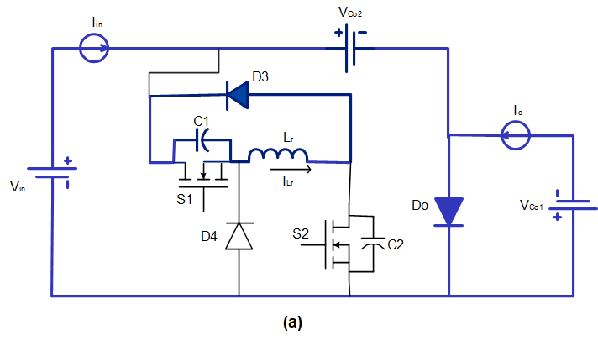

Fig. 3 C₁-capacitor charging.

The converter waveforms' expressions are discovered.
$$V_{C1}\left(t\right)=Z_{1}\left(I_{in}+I_{o}\right)sinω_{1}t$$
$i_{Lr}\left(t\right)=\left(I_{in}+I_{o}\right)cosω_{1}t$ (1)
$$V_{C2}\left(t\right)=V_{C02}$$

Where:
$Z_{1}=\sqrt{\frac{L_{r}}{C}}$ and $ω_{1}=\frac{1}{\sqrt{L_{r}C}}$ (2)
$$C=C_{1}=C_{2}$$

S₁ and S₂ were considered to be identical switches. The initial conditions are as follows:
V_{C1}(0) = 0 , V_{C2}(0) = V_{C02} , I_{Lr}(0) = I_{in}+I_{o}

And the final conditions are:

V_{C1} (t₁) = V_{C2} (t₁) = V_{Co2},
$I_{Lr}\left(t\right)=(I_{in}+I_{o})\sqrt{1-∝}$
With
$∝=\frac{V_{C02}}{Z1\left(I_{in}+I_{o}\right)}$

indicating the length of the first stage

$t_{1}=\frac{\sin^{-1}{∝}}{ω_{1}}$ (3)
V_{D4} equals 0 and D₄ is switched on with ZVS when V_{C1} reaches V_{C02}. Indicators of the commutation include zero capacitive turn-on losses.

Stage b: Discharging of a Resonant Inductor (t₁-t₂):
The inductor current I_{Lr} is discharged along the link D_{o}-V_{C02}-D₃-L_{r}-D₄ until it reaches zero. D_{o} passes all of the current (I_{in}+I_{o}+I_{D3}). This phase, which is seen in Fig. 4, is crucial to the converter design. A resonant inductor current peak is prevented by discharging the inductor before the multi resonance stage.
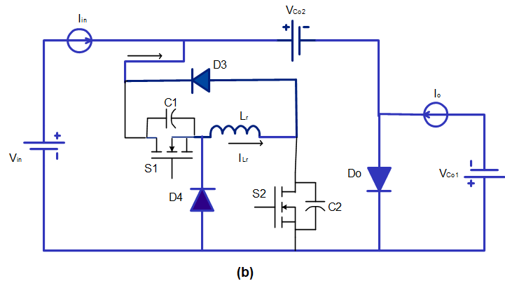

Fig. 4. Resonant inductor discharging.
The waveform expressions are as follows:
V_{C1}(t) = V_{C02},
V_{C2}(t)= V_{C02}
$I_{Lr}\left(t\right)=(I_{in}+I_{o})\sqrt{1-∝}-\frac{V_{C02}}{L_{r}}$ (4)
V_{C1}(t₂) = 0, V_{C2}(t₂)= 0, I_{r}(t₂)=0

When the stage is complete. The duration of the stage is:
$t_{2}=\frac{(I_{in}+I_{o})\sqrt{1-∝}}{V_{C02}}L_{r}$ (5)
D₃ and D₄ are naturally switched off when I_{L} is zero.
Stage c: Three-Element Resonance (t₂-t₃):
At this stage Fig. 5 is. When Lr, C₁ and C₂ resonant, V_{C1}, V_{C2} and I_{Lr} simultaneously go to zero. This circumstance causes S₁ and S₂ to switch on at zero voltage and zero current.
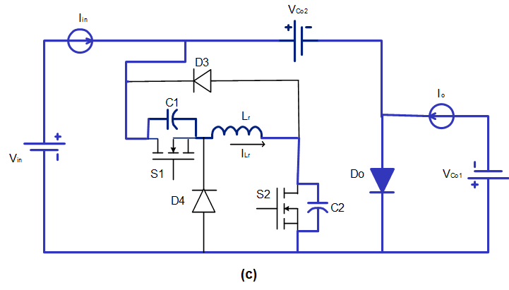

Fig. 5. Three-element resonance.

Unlike other converters discussed in the literature, the switches do not experience capacitive turn-on loss, because they are only activated when the current and voltage are zero. The following list includes the current and voltage expressions.
$V_{C1}\left(t\right)=V_{C2}\left(t\right)=\frac{V_{C02}}{2}\left(\cos{ω_{e}}+1\right)$
$I_{Lr}\left(t\right)=-\frac{V_{C02}}{Z_{e}}\sin{ω_{e}}$ (6)
$I_{Do}\left(t\right)=\left(I_{in}+I_{o}\right)-I_{Lr}\left(t\right)$

Where:
C=C₁=C₂ and $ω_{e}=\frac{1}{\sqrt{L_{r}\left(\frac{C}{2}\right)}}$ (7)
The duration's end is established by
V_{C1}(t₃) = 0 , V_{C2}(t₃) = 0 , I_{r}(t₃) = 0
$t_{3}=\frac{π}{ω_{e}}$ (8)
The largest absolute value of I_{Lr} at this stage is
$I_{Lr_max}=\frac{V_{C02}}{Z_{e}}$ (9)Since C is a parasitic capacitance of nF order, L >> C suggests that (9). At this time, the flow of current via D_{o} is
$I_{Do}\left(t\right)=\left(I_{in}+I_{o}\right)+\frac{V_{C02}}{Z_{e}}\sin{ω_{e}}$ (10)
with
$I_{Do_max}=\left(I_{in}+I_{o}\right)+\frac{V_{C02}}{Z_{e}}$ (11)
The only switch in the proposed circuit to experience overload in this way is this one. However, since (9) is so little, this pressure does not need an increase in the D_{o} rating.

Stage d: Resonant Inductor Charging (t₃-t₄):
As illustrated in Fig.6, the first thing that happens is that S₁ and S₂ are activated by ZVS. The commutation has no turn-on capacitive losses. A linear rise in inductor current occurs until it In this phase,
V_{C1}(t) = 0 , V_{C2}(t) = 0 , $I_{Lr}(t)=\frac{V_{C02}}{L_{r}}t$ (12)
with the final conditions
V_{C1}(t₄) = 0 , V_{C2}(t₄)= 0 ,
$I_{Lr}(t_{4})=\left(I_{in}+I_{o}\right)$

giving the interval duration as
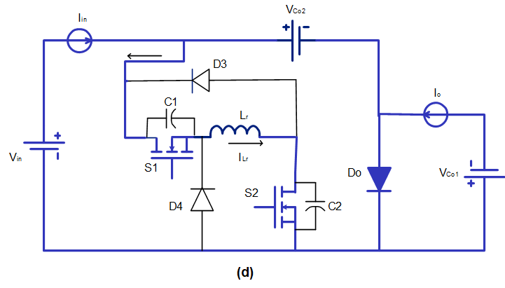

Fig. 6. Resonant inductor charging.

$t_{4}=\frac{\left(I_{in}+I_{o}\right)L_{r}}{V_{C02}}$ (13)
As
$I_{Do}=\left(I_{in}+I_{o}\right)-I_{Lr}$

When the duration reaches zero, I_{Do} also goes to zero, and D_{o} automatically turns off.
Stage e: Controlled (t₄-t₅):

During this stage as in Fig.7.
V_{C1}(t) = 0 , V_{C2}(t) = 0 , I_{Lr}(t) = I_{in}+I_{o} (14)

During this duration, the input is disconnected from the output, and a steady current flow from the input filter inductor and the output filter inductor to the resonant inductor L_{r}.
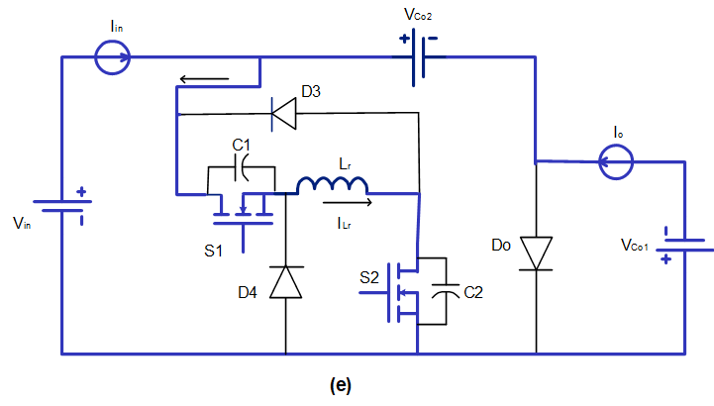

Fig. 7. Controlled stage

The duration of this stage is controlled by the feedback loop to regulate the output voltage
$D=\frac{t_{5}}{T_{s}}=\frac{V_{o}}{V_{o}-V_{i}}$ (15)

Stage f: C₂-Capacitor charging (t5 - t6):
Stage "f" operation begins when S₂ is opened at ZVS to begin charging C₂ at a constant current, as indicated in Fig. 8
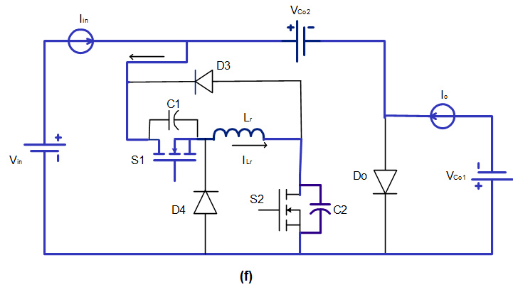
.

Fig.8. C₂-capacitor charging.
Diodes D₃ and D_{o} conduct to terminate the current stage when V_{C2} equals V_{C02}.

$v_{C2}(t)=\frac{\left(I_{in}+I_{o}\right)t}{C_{2}}$
$i_{Lr}(t)=\left(I_{in}+I_{o}\right)$ (16)
$i_{Do}\left(t\right)=0$

At the end of this stage v_{C2}(t₆) = V_{C02} and the duration is:
$t_{6}=\frac{V_{C02}C_{2}}{\left(I_{in}+I_{o}\right)}$ (17)

Stage g: freewheeling mode (t6 - t7):
During this phase, as seen in Fig. 9, the energy stored in the filter inductor is transferred to the output capacitor and load while the current in L_{r} freely circulates via D₃ and S₁. The duration's conclusion is dictated by
V_{C1}(t₇) = 0 , V_{C2}(t₇)= V_{Co2} ,
I_{Lr}(t₇)=I_{in} +I_{o} , I_{Do}(t₇) = I_{in} +I_{o} (18)

This description of a converter allows for soft switching without any losses due to capacitive turn-on. The extra conduction loss on switch S₂ is the cost of this achievement. However, S₂ is only used in two stages, reducing losses significantly.
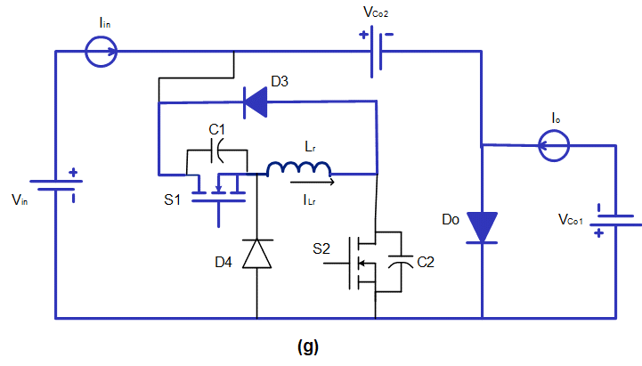

Fig.9. Free-wheeling stag.
III. Characteristic and design parameter
Using the output power and switching duty ratio, we can derive the values for L_{fo}, L_{f1}, L_{r}, C₁, C₂, C₀₁, and C₀₂ in the circuit design of the edge-resonant modules. This section provides a description of the resonant modules L_{r} and C₁ to demonstrate a design principle. The highest output power P_{o-max} and the associated duty ratio D_{max}, as well as the lowest output power P_{o-min} and the related duty ratio D_{min}, are utilized to derive the circuit design parameters L_{r} and C₁. For edge-resonant soft-switching, the output power is varied from P_{o-min} to P_{o-max}. The maximum time for soft switching at an edge resonance, denoted by t_{max}, is equal to D_{max}T_{s}. When the resonant capacitors C₁ and C₂ are discharged to zero and the switches S₁ and S₂ are activated, the minimal edge-resonant soft-switching time t_{min} occurs. Therefore, the minimal output power, P_{o-min}, may be used to determine the value of the resonant capacitors C₁ and C₂. One switching period T_{s} must be greater than S_{1-min}, the minimum time required for the complete discharge of the resonant current, in order to accomplish soft-switching commutation. Calculating the minimum time required for a complete discharge, S_{1-min} [4], allows one to determine the resonant inductor L_{r}.
The capacitor voltages V_{C1} and V_{C2} must be drained to zero at the end of Stage "c" in order to provide a condition for ZVS, and this is possible if V_{C1} = V_{C02} at the end of Stage "a". It may be shown that both of the aforementioned requirements can be met if

$L_{r}=\frac{V_{co2,max}}{\left(I_{in}+I_{o,min}\right)}$ (19)

Which provides the L_{r} design value.

IV. Simulation results
In Fig.10, we see a MATLAB simulation of the mentioned circuit run with the following parameters: A constant current source sink was modeled for L_{f1} with V_{in} = 12 V, V_{o} = -24 V, Iin = 2 A, I_{o} = 2 A, L_{r} = 15 µH, C₁ = C₂ = 20 nF, Lfo = 300µH, C₀₁ = 250µf, C₀₂ = 100µf, and a switching frequency of f_{s} = 100 kHz. The outcomes obtained via Simulink are shown in Fig. 11 and 12, respectively. Because V_{C1}, V_{C2}, and I_{Lr} all reach zero before S₁ and S₂ are switched on, the MATLAB simulation makes it very evident that neither S₁ nor S₂ have any voltage or ZCS before they are turned on.

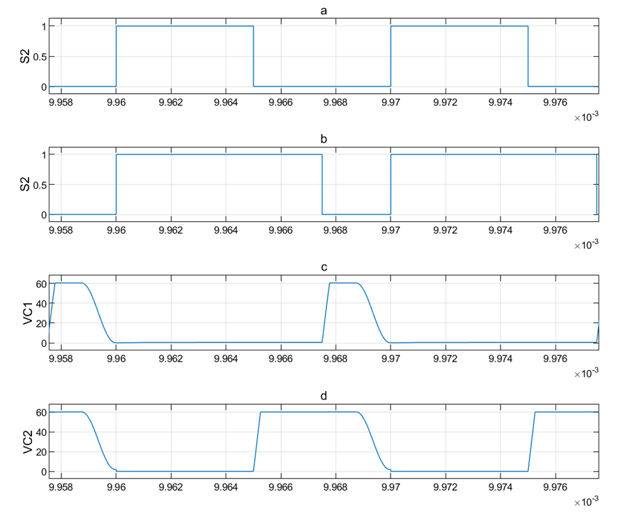

Fig.10. complete circuit of the CUK converter
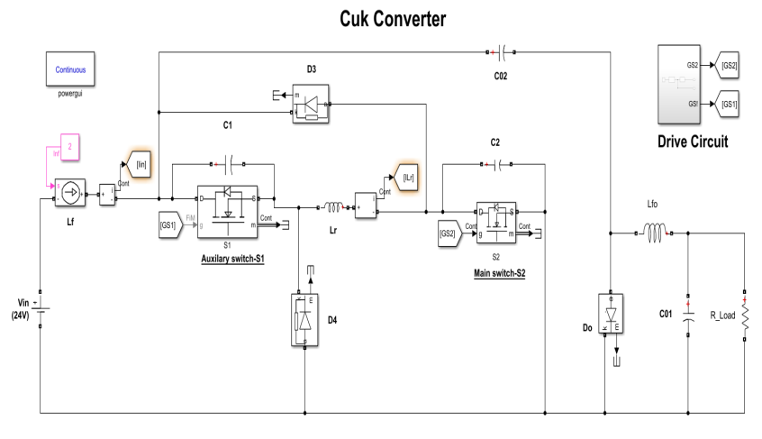
Fig.11: Simulation results of the Cuk converter:
a) Gate of the switch S₂ b) Gate of the switch S₁
d) Voltage capacitor C₁ d) Voltage capacitor C₂
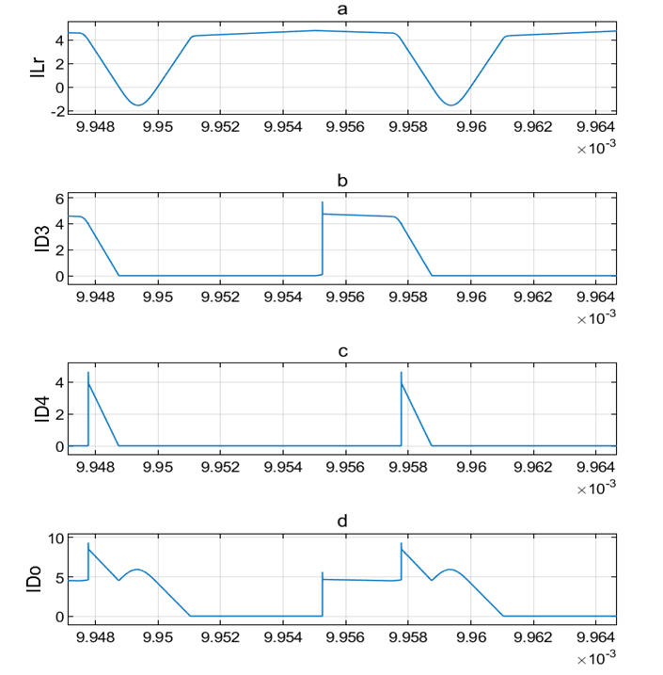

Fig.12: Simulation results of the Cuk converter:
a) Current inductor L_{r} b) Current diode D₃
d) Current diode D₄ d) Current diode D_{o}

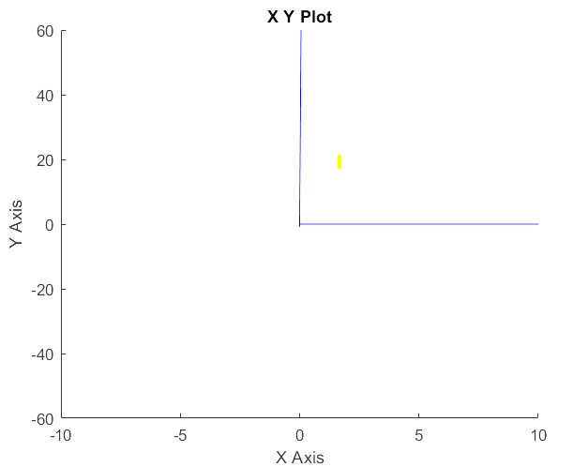
The V–I curves of the two switches are shown in Figure 13, and they demonstrate that both S₁ and S₂ operate in soft switching, just as the simulation in Matlab predicted they would.

V_{S1}
I_{S1}

(a)

V_{S2}
I_{S2}

(b)
Fig. 13: The switching trajectories of S₁ and S₂.
a) V-I diagram of S₁, b) V–I diagram of S₂

V. EXPERIMENTAL RESULTS
In the laboratory, a prototype was constructed with the following requirements and constraints: V_{in} = 12 V, V_{o} = (11.5 - 60) V; I_{in} =2 A; I_{o} = (1 - 6.3) A, L_{r} = 15µH; C₁ = C₂ = 20 nF , L_{fo}=300µH , C₀₁=250µf , C₀₂=100µf; and the switching frequency fs = 100 kHz. MOSFETS model IRF542 and diodes model MBR20100 were selected for use in the prototype. Fig. 14–18 illustrate the experimental waveforms that were acquired from the prototype. The results emphasize the ZVS and ZCS of S₁ and S₂ when V_{C1}, V_{C2}, and I_{Lr} all arrive to zero at the same time before S₁ and S₂ are switched on. The converter achieves excellent regulation for a change in input voltage in the range of 12–24 V and a change in load current of 1–6.3 A. It also has an efficiency of over 96 percent over the whole range of specifications for which it was designed.
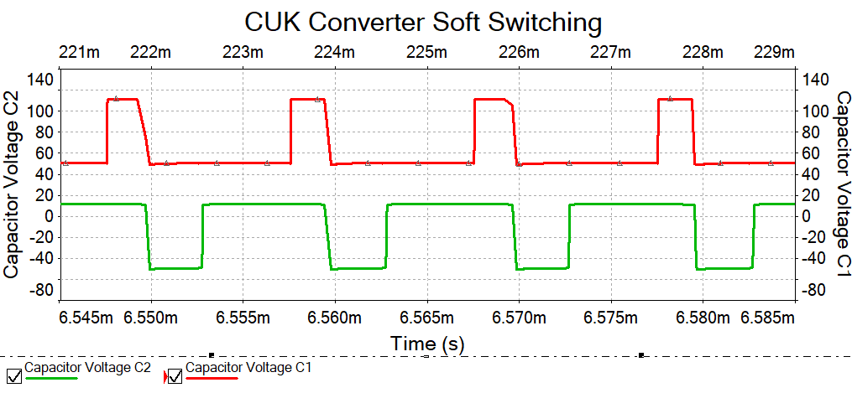
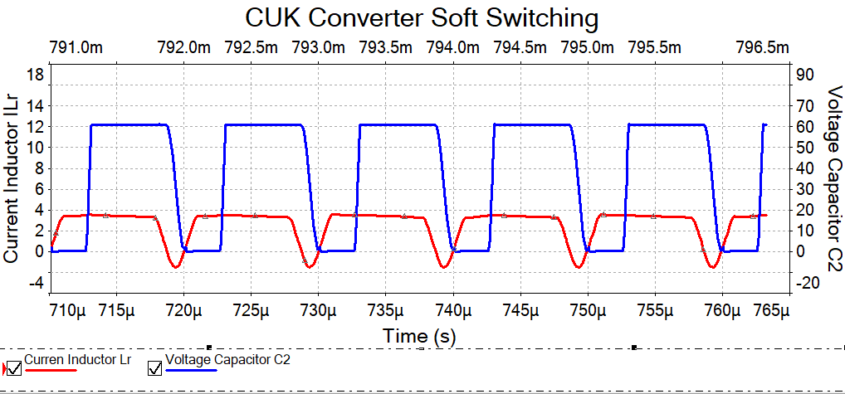
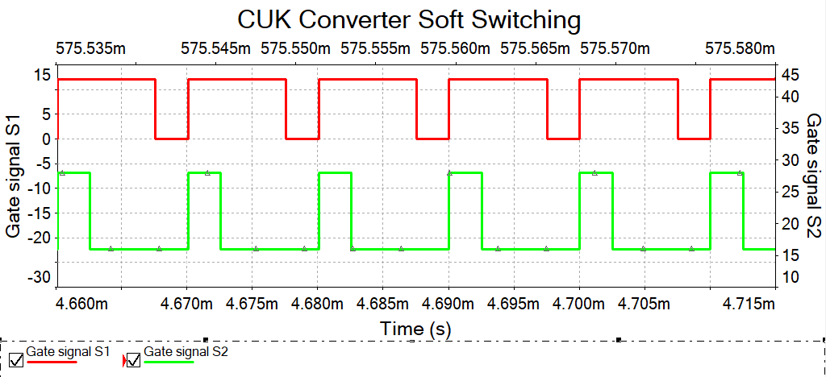
Fig.14 :Experimental results of the gate signals to S₁ and S₂.

Fig.15 :Experimental results of waveforms of V_{C2} and I_{Lr}.

Fig.16 :Experimental results of waveforms of V_{C2} and V_{C1}.

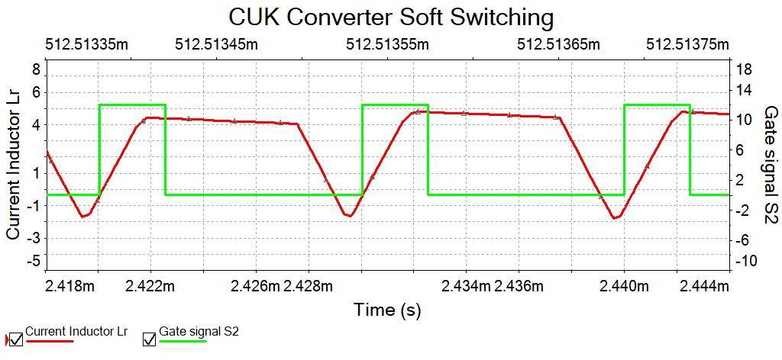
Fig.17 :Experimental results of waveforms of I_{Lr} and S₂.

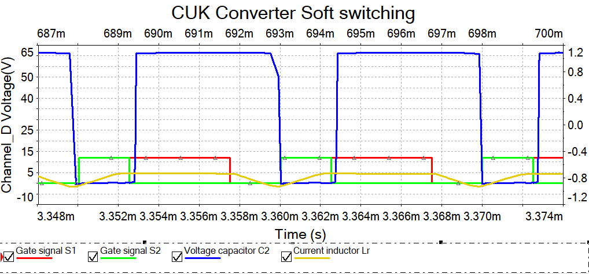
Fig.18 :Experimental results of waveforms of S₁, S₂, I_{Lr} and V_{C2}.

VI. Efficiencies and power loss aspects
The following formula can be used to calculate the overall power consumption losses of the proposed converter circuit.
$P_{loss_total}=P_{cond_S2}+P_{sw_S2}{+P}_{con_S1}+P_{sw_S1}+P_{con_D3}+P_{sw_D3}+P_{cond_D4}+P_{sw_D4}+P_{cond_Do}+P_{sw_Do}$ (20)
In this regard, the energy losses of the inductor and capacitor parts have been omitted, and the losses of the auxiliary switch and diodes are considered to be minimal due to the brief duration of operation. When compared to a normal Cuk converter, there is no additional voltage stress delivered to the converter, therefore the main diode and switch do not experience an increase in their conduction losses [11]. This is the reason why there is no increase in the conduction losses of these components.
$ƞ=\frac{\left(P_{in-}-P_{loss_total}\right)}{P_{in}}$ (21)
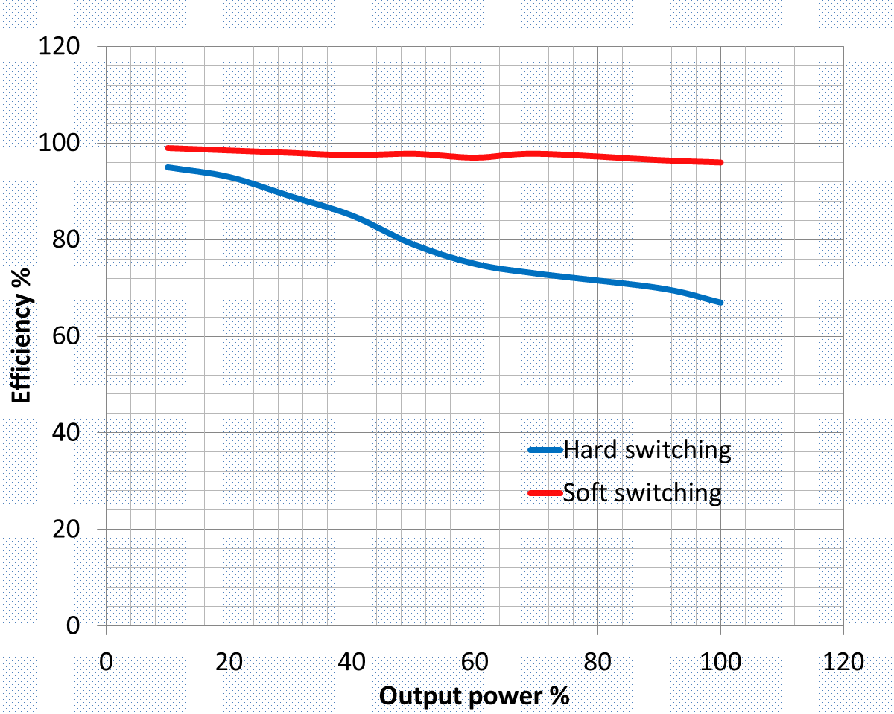

Fig. 19. Comparing SS and HS converter efficiency curves.

As can be shown in Fig. 19, with maximum output power of 375W and 100 kHz of the switching frequency, the new converter achieves an overall efficiency of 96%. The efficiency is nearly identical to that of a comparable converter described in [10], whose circuit works at 5 kW and 50 kHz nominally. Moreover, it can be shown that the efficiency levels are higher than those of most other SS converters, even at low output powers. As the load current decreases in the new converter, the converter loss likewise decreases, as it is very sensitive to recirculated energy. Finally, it was found that the theoretical analysis of the suggested ZVT–Cuk converter was perfectly confirmed by the simulation and experimental results.
VII. CONCLUSION
In this study, a novel edge-resonant Cuk converter is presented. Using simulation results, this study confirmed zero-voltage and zero- current turn on switching and zero-voltage during turn off switching in the commutation Cuk converter. The expert design of the Lr value allows the ZVS to be maintained throughout a large line and load range. The benefit of this converter is that it improves circuit power efficiency and decreases switch power loss. At high power and high frequency levels, a MOSFET-PWM converter is especially well suited to it. The suggested auxiliary circuit is also inexpensive, easy to operate, and has a simple construction. The converter with the suggested auxiliary circuit can run smoothly with soft switching at much higher frequencies and light load circumstances. The multiple-input soft-switching Cuk converter's closed-loop control technology will be the subject of future research

VIII. References
[1] B. P. Divakar and A. Ioinovici, “PWM converter with low stresses and zero capacitive turn-on losses,” IEEE Trans. Aerosp. Electron. Syst., vol. 33, no. 3, pp. 913–920, 1997.
[2] R.-J. Wai, R.-Y. Duan, J.-D. Lee, and L.-W. Liu, “High-efficiency fuel-cell power inverter with soft-switching resonant technique,” IEEE Trans. Energy Convers., vol. 20, no. 2, pp. 485–492, 2005.
[3] S. Surya and V. Patil, “Cuk converter as an efficient driver for LED,” in 2019 4th International conference on electrical, electronics, communication, computer technologies and optimization techniques (ICEECCOT), 2019, pp. 49–52.
[4] Z. Sun and S. Bae, “Multiple-input Soft-switching Ćuk Converter,” in 2017 IEEE Energy Conversion Congress and Exposition (ECCE), 2017, pp. 2272–2276.
[5] C.-J. Tseng and C.-L. Chen, “Zero-voltage-transition topologies for Cuk converters,” in PESC 98 Record. 29th Annual IEEE Power Electronics Specialists Conference (Cat. No. 98CH36196), 1998, vol. 2, pp. 930–935.
[6] B. P. Divakar, K. W. E. Cheng, and D. Sutanto, “Zero-voltage and zero-current switching buck-boost converter with low voltage and current stresses,” IET Power Electron., vol. 1, no. 3, pp. 297–304, 2008.
[7] C. A. Canesin and I. Barbi, “Novel zero-current-switching PWM converters,” IEEE Trans. Ind. Electron., vol. 44, no. 3, pp. 372–381, 1997.
[8] N. S. Ting, I. Aksoy, and Y. Sahin, “A new zero-voltage-transition pwm dc-dc boost converter,” in 2015 Intl Aegean Conference on Electrical Machines & Power Electronics (ACEMP), 2015 Intl Conference on Optimization of Electrical & Electronic Equipment (OPTIM) & 2015 Intl Symposium on Advanced Electromechanical Motion Systems (ELECTROMOTION), 2015, pp. 257–262.
[9] H. Mao, F. C. Y. Lee, X. Zhou, H. Dai, M. Cosan, and D. Boroyevich, “Improved zero-current transition converters for high-power applications,” IEEE Trans. Ind. Appl., vol. 33, no. 5, pp. 1220–1232, 1997.
[10] H. Bodur and A. F. Bakan, “An improved ZCT-PWM DC-DC converter for high-power and frequency applications,” IEEE Trans. Ind. Electron., vol. 51, no. 1, pp. 89–95, 2004.
[11] B. Arbetter, R. Erickson, and D. Maksimovic, “DC-DC converter design for battery-operated systems,” in Proceedings of PESC’95-Power Electronics Specialist Conference, 1995, vol. 1, pp. 103–109.

